Syracuse startup wins the opportunity to impact freshwater lakes

By Morgan Grenz

*CEO and founder of Eget Liber in his office at the Tech Garden showing his designs on how he plans to improve his product. Photo by Morgan Grenz.*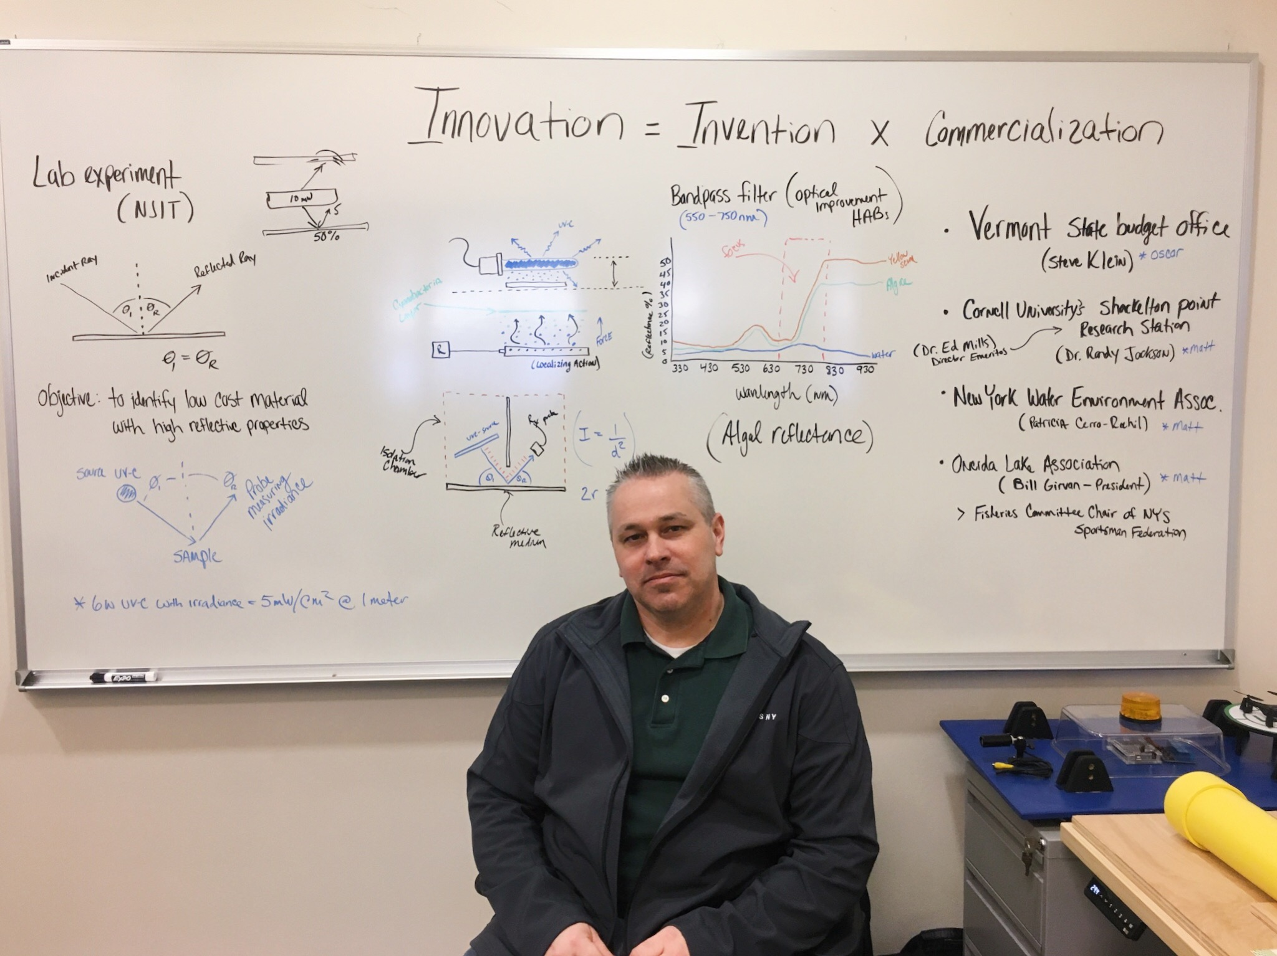

SYRACUSE, N.Y.- Eight months ago a science teacher Googled summertime environmental problems for Upstate NY, now he has a startup developing drone technology to solve one of the most pressing environmental issues not only in the area, but across the country.

Eget Liber is developing autonomous, semi-submersible remotely operated underwater vehicles that use ultraviolet light to kill cyanobacterium, also known as blue-green algae, in freshwater lakes. Jason Dean, CEO and founder of Eget Liber, entered his idea in the Genius NY business competition and is now one of five finalists.

In January, the finalists moved into The Tech Garden, a technology incubator in downtown Syracuse, where they will be given the chance to compete for capital while accessing business building services, according to their website.

Dean had previously been associated with The Tech Garden when about a year and a half ago he went to them for help in developing a tick removal apparatus. He said he wanted to create the device after his niece became partially paralyzed from a tick bite. The device collects and removes ticks without any chemicals.

While working on the project, Dean said he caught a glimpse of that year’s Genius teams and was intrigued.

“The Genius group was always this elevated group that you would hear about- you know this mysterious Genius group in the back,” Dean said. He remembers wondering how he could become a part of it.

*The entrance to the Genius center facilities in The Tech Garden. Photo by Morgan Grenz*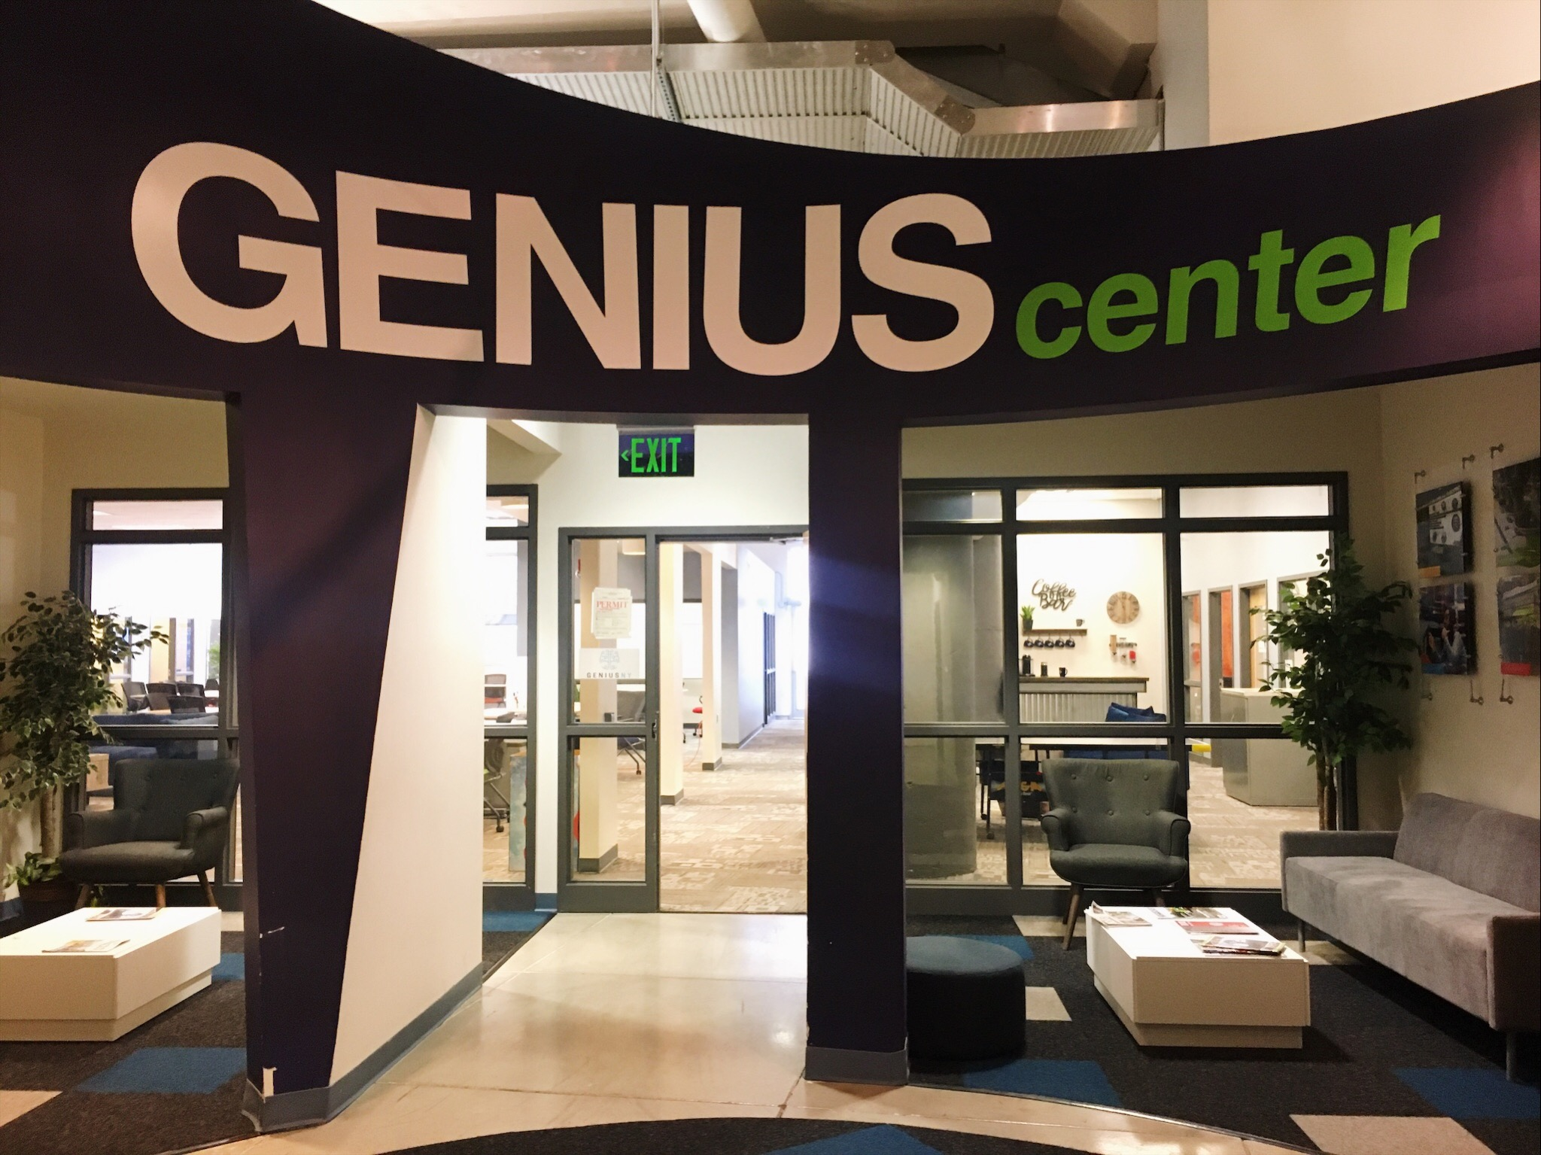

Genius NY is the world’s largest business accelerator competition for unmanned systems. More than 400 companies applied this year from 17 countries. The five finalists were chosen through multiple rounds of judging and will now occupy The Tech Garden offices.

The director of the accelerator program, Jeff Fuchsberg, explained that once the finalists move in, they are in what is considered “phase one” of the program. This phase is “very sort of rigorous and curriculum based, where they produce their business case, a pitch deck...and work on the actual investor presentation,” Fuchsberg said.

Phase one concludes on Finals Night, April 22, where the teams will compete in a large public facing event, according to Fuchsberg. The top team will win $1 million and the four remaining teams will receive $500,000.

“The focus isn’t on $1 million, because I know firsthand, there’s so much more that comes with this organization than the money,” Dean said.

Dean described the moment he found out he was in the final five as having a weight lifted off his shoulders. Having a wife and children who depend on him, Dean said putting the time and money into this competition was a gamble. He felt a sigh of relief knowing that it became a reality.

The remainder of the year will be focused on operations and connecting the teams with mentors, according to Fuchsberg. There is a team of seven executive advisors associated with the program from industry and the investment community. Fuchsberg said they will also bring in various business professionals.

“The intent is that all of these teams, regardless of where they come from, will continue to have a significant Central NY presence,” Fuchsberg said.

Eget Liber takes a new approach to blue-green algae mitigation by reducing the negative effects that occur with existing processes. Dean explained that “Eget Liber” comes from a Latin phrase meaning “chemical free,” which goes hand in hand with their thought process and how they tackle environmental problems.

The system includes a drone that is able to fly above an area to photograph and map out the algae. This information is then sent back to the robotic vehicle on the water, which chooses the optimal route for collecting the algae. As the vehicle is traveling through the lake, the algae flow through the body of the vehicle and filtered back out the other end.

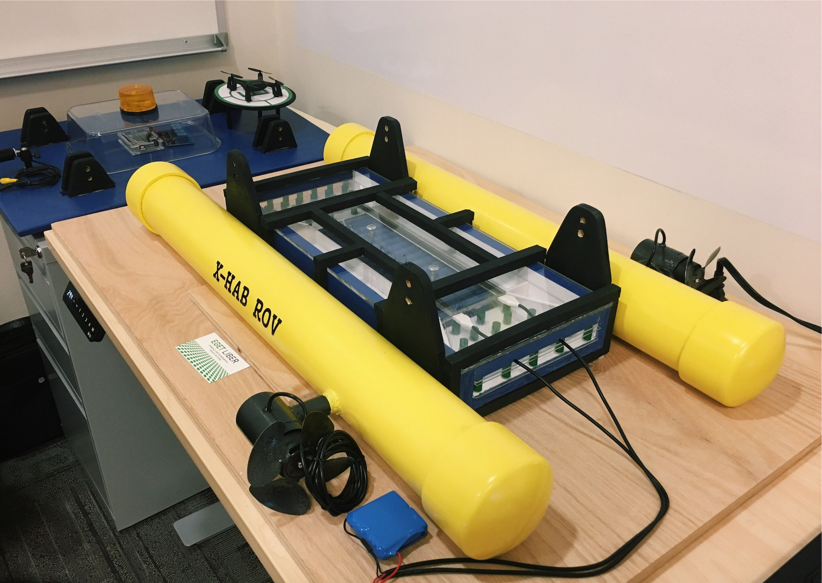

*A prototype of Eget Liber’s vehicle in Jason Dean’s office at The Tech Garden. Photo by Morgan Grenz.*

Dean explained that as the algae passes through, it enters an irradiance chamber, which uses light to break down the cellular walls and disrupt the DNA of the bacteria. This process causes the algae not to come back since it can no longer replicate or reproduce.

According to the NYS Department of Health, exposure to any blue-green algae blooms can cause health effects in people and animals when water with blooms is touched, swallowed, or when airborne droplets are inhaled. These concerns cause public beaches to shut down, fishing restrictions and public water supplies to be closely monitored.

\*\*insert quote by ESF Professor about the dangers of blue-green algae\*\*

“I have kids and hopefully I’ll have grandkids and great grandkids and obviously I’ll have generations that I will never end up meeting. But you want to leave something behind that’s a little better. At least not worse than the way you found it,” Dean said.

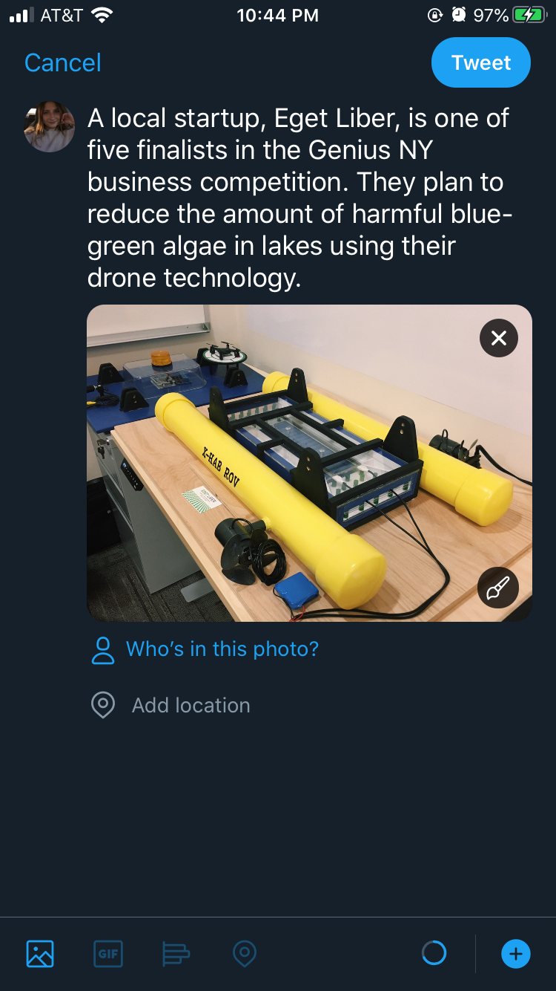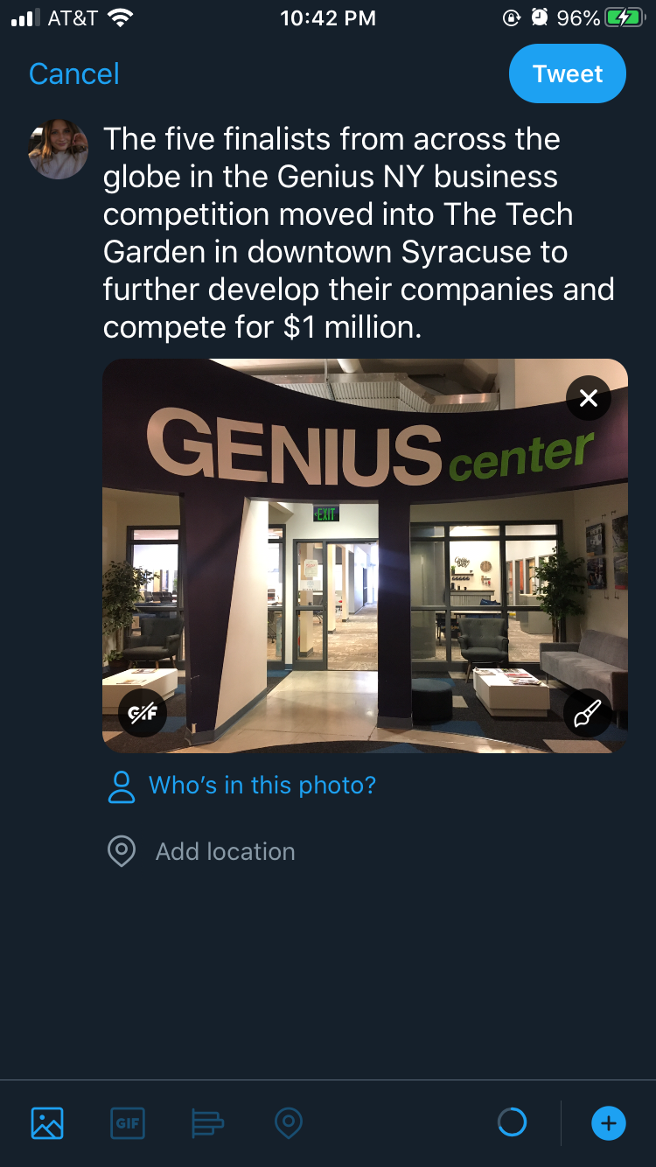Social Media: